Concept Note and Agenda

International Forum

“The Gender Dimensions of Climate Change and Disaster Risk Management”
November 23-24, 2010
Mexico City

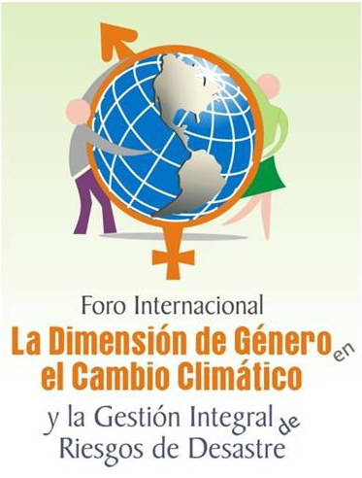

November 10, 2010

EVENT STRUCTURE

The Forum is hosted by the Government of Mexico: Ministry of the Environment and Natural Resources (SEMARNAT), National Institute of Ecology (INE), Ministry of Foreign Affairs (SRE), National Institute for Women (INMUJERES), General Coordination Office for Civil Protection (GCOCP), Ministry of the Interior (SEGOB)); the United Nations Development Programme (UNDP) and the Heinrich Böll Foundation (HBF) in collaboration with the Global Gender and Climate Alliance (GGCA).

Date: November 23-24

Venue: Hilton Reforma Hotel, Mexico City

Number of participants: 250 national and international participants and guests

Profile of participants and guests

This forum will bring together civil society, academia, grassroots and government representatives from diverse regions (Central America, Latin America and the Caribbean, Africa, Asia, Arab States and Asia Pacific).

BACKGROUND

The complexity of climate change is such that it is not only important, but also necessary to create an inclusive and open space where climate actors from around the world can share experiences, strengthen initiatives, generate innovative proposals or recommendations, expand their network of resources.

A gendered and rights-based analysis of climate action is needed to inform and enrich policy options in across countries and cultural contexts.

Objectives

- To create an open space for the analysis and debate of the main thematic issues regarding gender, disaster risk management and climate change at the international, regional and national levels, and to generate groundbreaking proposals on mitigation, adaptation, financing and public policy from a gender perspective toward COP16.
- To share experiences and knowledge, formulate best practices, and identify strategies for a gender and climate change agenda that can later be applied to public policy and financing.

Particular Objectives

- To share best practices from governments, civil society, international development agencies and others actors, in order to identify the main agenda of gender and climate change.
- To discuss the status of international negotiations regarding gender and climate change.
- To identify necessary actions for incorporating a gender and human rights perspective into public policies on climate change.

Meeting Results
- Recommendations and proposals for integrating gender and human rights into climate change adaptation, mitigation and financing negotiations during and beyond COP16, at the international and national levels.

METHODOLOGY

After the opening ceremony magisterial lectures will establish the conceptual framework of subsequent sessions. Four major themes have been chosen for the plenary session to provide a comprehensive overview on gender and climate change: “The general framework of the international negotiations on climate change,” “The challenges of climate change and disaster risk management from a gender perspective,” “Climate change from the human rights and gender perspective,” and “Gender and climate change: the challenge of public policies.”

The magisterial lectures will be followed by four parallel sessions: “Risk management”; “Water, sanitation and health”; “Public policies, gender and climate change”; and “Agriculture and food security”. In each session three to five international and national case studies will be presented, followed by a question and answer session.

To secure a space, participants should select and register for a parallel session that matches their interest and/or expertise. The maximum number of participants per session will be 65.

At the end of each parallel session, the chairs and the rapporteurs will systematize each session´s information and outputs with regard to three major categories: adaptation, mitigation, financing.

On Day 2, three parallel sessions will be held on adaptation, mitigation and financing. In each session a magisterial lecture will be presented, after which a Q&A session will be opened followed by a summary of the outputs of the Parallel Sessions I.

Parallel Sessions II will be followed by the plenary session “Outputs of Parallel Session II: Adaptation, Mitigation and Financing”. This analysis seeks to generate additional recommendations for developing public policy at national and international levels.

In the afternoon, a special session for international participants will be held on: 1) achievements, 2) where and why we are falling short, and 3) the challenges we are facing towards COP 16 and beyond.

AGENDA

DAY 0: Monday 22 November
All Day | Arrival of International Participants

DAY 1: Tuesday 23 November
7:00-8:00 |  | Breakfast
8.00 – 9.00 |  | International Forum Registration Opens
9.00 – 10-00 |  | Inaugural Ceremony
Chair |  | TBD
 |  | This ceremony will feature opening remarks by esteemed officials and partners. Distinguished guests from the Mexican Government, international agencies, and academia will be in attendance.
Juan Rafael Elvira Quesada
Minister, SEMARNAT (TBC)

Sandra Herrera
Undersecretary of Regulation and Development, SEMARNAT

Laura Gurza Jaidar
Coordinator, GCOCP - SEGOB

Maria del Rocio Garcia Gaytan
President, INMUJERES

Magdy Martinez-Soliman
Resident Representative, UNDP/Mexico

Ingrid Spiller
Representative of the Regional Office for Mexico, Central America and the Caribbean, HBF

Luis Alfonso de Alba
Ambassador, Special Representative on Climate Change, SRE

10.00-10.15 |  | Coffee Break
10:15-12:55 |  | Magisterial Lectures
Chair |  | Itza Castañeda  Senior Gender Advisor, UNDP/Mexico
10.15-10.55 |  | Magisterial lecture 1: The General framework of the international negotiations on climate change  Adrian Fernandez Bremauntz  President, INE
10.55- 11.35 |  | Magisterial lecture 2: The challenges of climate change and disaster risk management from a gender perspective  Lorena Aguilar Revelo  Senior Gender Global Advisor, IUCN
11.35-12.15 |  | Magisterial lecture 3: Climate change from the human rights and gender perspective  Javier Hernandez Valencia  Representative, OHCHR-Mexico
12.15 – 12.55 |  | Magisterial lecture 4: Gender and climate change: the challenge of public policies  Rachel Shebesh  Member of Parliament of the Republic of Kenya and Chair of the African Parliamentarian Initiative for Climate Risk Reduction
English Rapporteur |  | Hannie Meesters  Policy Specialist on Climate Change and Gender, UNDP Gender Team
Spanish Rapporteur |  | TBC
13.00 – 14.30 |  | Lunch
14.30-18.00 |  | Parallel Sessions I  A comprehensive analysis of the causes and effects of climate change from the gender perspective  These parallel sessions are organized thematically and will focus on gender and climate change experiences  and case studies.
 |  | Session 1:  Integral risk management | Session 2:  Water, sanitation and health |  | Session 3:  Public policies, gender and climate change |  | Session 4:  Agriculture and food security
14:30-14:50 |  | Introduction to the sessions: exposition of the objectives, work dynamic and programme; introduction of the panelists; and brief presentation of the subject related to the session.
Chairs |  | Karen Bernard  Programme Specialist,  UNDP/Pacific Centre | Ana Ella Gomez  Independent Consultant |  | François Rogers  Special Gender Advisor, IUCN |  | Jorge Villarreal  Programme Coordinator, HBF Mexico
14:50-16:05 |  | Enhancing gender visibility in disaster risk management and climate change in the Caribbean. Country assessment report  Jacinda Fairholme  CRMI,  UNDP/Cuba | Impact of climate change on water and sanitation in Jamaica  Linette S. Vasell  Community Development & Gender Specialist,  Women´s Resource & Outreach Centre |  | Regional overview on the pacific gender issues. The pacific climate change strategy  Netatua Pelesikoti  Programme Coordinator,  SPREP |  | Gender and climate change: South African case study  Agnes Babugura  Lecturer  Geography and Environmental Science Department, Monash University South Africa
 |  | Securing food, livelihoods and influencing development after hurricane Mitch, Honduras  Ana Lucy Bengochea  Director of the Emergency Garifuna Committee,  GROOTS | Closing the health gap in tsunami-hit districts of Tamil Nadu Ashaa women’s Groups and Swayam Shikshan Prayog, India Asha Sitaram  Suranjana Gupta  Coordinator of the Global Campaign on Resilience,  Huairou Commission |  | Gender mainstreaming in the third communication, Jordan  Fidaa Haddad  Project Coordinator,  IUCN |  | Impact of climate change on agriculture on an indigenous community  in Guyana  Paulette Bynoe  Director, School of Earth & Environmental Sciences  University of Guyana
 |  |  | Exposition and analysis of the available information that shows the diverse impacts that climate change has on women and men´s health and gender norms, rules and relationships  Elena Villalobos  Department of Public Health and Environment (PHE)  Gender focal point  World Health Organization |  | Gender and climate change regional strategy, Central America  Haydee Castillo  Regional Coordinator, FMICA |  | The challenges of planning and managing Pacific coastal fisheries and the impacts of climate change: a gender perspective  Veikila Vuki  Coordinator, Marine Laboratory  University of Guam
 |  | Climate risk prevention with gender equality in San Felipe Yucatan  Xavier Moya Garcia,  UNDP/Mexico | Hilda Salazar Ramirez  REGEMA |  | Julia Martinez Fernandez  Climate Change Programme Coordinator, INE |  | Actions of indigenous women in Brazil within a food security and environment sustainability framework  Lylia da Silva Guedes Galetti  Coordinator of Indigenous Matters, Ministry of Environment, Brazil
 |  |  |  |  |  |  | Mexican Experience (TBD)
16:05-16:20 |  | Q&A
16:20-17:35 |  | Analysis and Discussion
17:35-18:20 |  | Integration of proposals
18:20-18:30 |  | Conclusions
English Rapporteur |  | Maite Rodriguez Blandon  Director, Guatemala Foundation | Karol Hernandez  Technical-Administrative Assistant, Water and Sanitation Project, UNDP/Mexico |  | Natalia Kostus  Program Manager, IUCN |  | Andrea Quesada  Consultant, IUCN
Spanish Rapporteur |  | Edwviges Rodriguez Deputy Director,Sustainability and Environment, INMUJERES | Brenda Rodriguez  REGEMA |  | TBD |  | Atene Duran  Gender Equity Director, SEMARNAT
20:00 |  | Dinner at the hotel
Day 2: Wednesday November 24

7:00-8:30 | Breakfast
9.00-11:00 | Parallel Sessions II:  Actions and public policies to address climate change from a gender perspective  These parallel sessions are organized around the three main climate change strategies.
9.00-11:00 | Session 1:  Adaptation |  |  | Session 2:  Mitigation |  | Session 3:  Financing
9:00-9:10 | Introduction to the sessions: exposition of the objectives, work dynamic; and introduction of the panelists
Chairs: | Verania Chao  Energy and Environment Program Director, UNDP/México |  |  | Anne Lice Hernandez  Area Director, CGPC-SEGOB |  | Julia Martinez  Climate Change Programme Coordinator, INE
9:10-9:30 | Yianna Lambrou  Senior Officer  Gender, Equity and Rural Employment Division, FAO |  |  | Ana Rojas  Asia Program Officer  ENERGIA |  | Mariama Williams  International Economics Consultant  South Centre
9:30-9:40 | Q&A
9:40- 9:50 | Outputs from Day 1 relative to adaptation |  |  | Outputs from Day 1 relative to mitigation |  | Outputs from Day 1 relative to financing
9:50-9:55 | Q&A
9:55-10:45 | Analysis of future actions and challenges to overcome
10:45-11:00 | Agreements and conclusions
English Rapporteur | Maria Jose Mesen  Sustainable Development Programme Manager, UNDP/Mexico |  |  | Maria Leticia Guelfi  Program Specialist  UNIFEM |  | Lucy Wanjiru  Climate Change and Gender Consultant,UNDP Gender Team
Spanish Rapporteur | Paulina Reyes  SEMARNAT |  |  | Laura Liselotte Correa  Sustainable Development Director, INMUJERES |  | Esmeralda Loyden  SEMARNAT
11:00-11:45 | Break (45 min)  Conclusions working group ( 45 min)
11.45-12:45 | Plenary session  Outputs of parallel sessions II: adaptation, mitigation and financing
11:45-12:00 | Introduction
12:00.12:15 | Outputs of adaptation parallel session  Verania Chao, Energy and Environment Program Director, UNDP/México
12:15-12:30 | Outputs of mitigation parallel session  Anne Lice Hernandez, Area Director, CGPC-SEGOB
12:30-12:45 | Outputs of financing parallel session  Julia Martinez Fernandez, Climate Change Programme Coordinator, INE
Chair: | Balbina Hernandez Alarcon  Equity and Human Rights General Adjoint Director ,UCPAST-SEMARNAT
12:45-13:00 | Declaration of Mexico
Chair: | Balbina Hernandez Alarcon  Equity and Human Rights General Adjoint Director, UCPAST-SEMARNAT
13.00-13.30 | Closing Ceremony  Mateo A. Castillo Ceja  Head of the Social Participation and Transparency Unit, SEMARNAT.  Maria Elena Alvarez Bernal  Executive Secretary, INMUJERES  Laura Gurza Jaidar  General Coordinator, CGPC- SEGOB  Maria del Rocio Garcia Gaytan  President of INMUJERES  Ana Güezmes  Regional Director for Central America, Cuba, Mexico and Dominican Republic, UNIFEM  Ingrid Spiller  Representative of the Regional Office for Mexico, Central America and the Caribbean, HBF
13:30-14:30 | Lunch  End of the International Forum

INTERNATIONAL SESSION: COP16 AND BEYOND

During Day 2, a specific session for international participants will be held to analyze and discuss the achievements reached in incorporating gender perspectives in the international climate change negotiations, where we are falling short in the international process and why, and the challenges towards COP 16 and beyond.

General Objective

To identify short- (COP 16) and medium-term strategies to strengthen the mainstreaming of gender perspectives in the international and national agendas on climate change.

Particular Objectives

- To identify achievements, challenges and opportunities
- To create a short -and medium- term roadmap

Day 2 Afternoon: Wednesday November 24

14.30-19.30 | International session COP16 & beyond
14.30-14.40 | Opening remarks and agenda presentation
14.40-15.00 | Main achievements  Carmen de la Cruz  Gender Practice Leader, UNDP Regional Office-Latin America and the Caribbean  Cate Owren  Programme Director, WEDO
15.00-16.30 | Identification of strategic lines of action  Work in groups
16.30-17.15 | Open space for dialogue and exchange
17.15-18.00 | Reflections and conclusions
18.00-19.00 | Advocacy strategies  (coordination and monitoring mechanisms)  Reflection in plenary
19.00-19.30 | Next steps and closing remarks
20:00-22:30 | Closing Cocktail

CASE STUDIES BY REGION
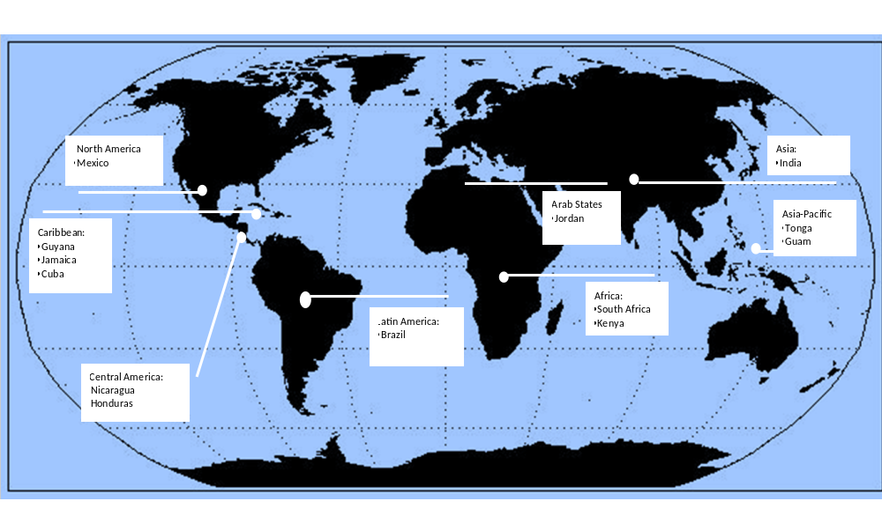

INTERNATIONAL PARTICIPANTS* (Working list as to November 9)

 | Name | Title | Duty Station
1 | Aguilar Revelo Lorena | Global Senior Gender Advisor, IUCN | Costa Rica
2 | Babugura Agnes | Lecturer, Monash South Africa | South Africa
3 | Bengochea Ana Lucy | Director, Emergency Committee Garifuna Honduras. Groots International/Huairou Commission | Honduras
4 | Bernard Karen | Programme Specialist  Natural Disaster Reduction & Transition  UNDP Pacific Centre | Fiji Islands
5 | Bynoe Paulette | Director, School of Earth & Environmental Sciences, University of Guyana | Guyana
6 | Castillo Haydee | Regional Coordinator, Women´s Fund for the Centroamerican Integration (FMICA) | Nicaragua
7 | Currea Ana Maria | Knowledge Management Facilitator, GEF Small Grants Programme | New York
8 | Da Silva Guedes Galetti Lylia | Coordinator of Indigenous Matters, Ministry of Environment | Brazil
9 | De la Cruz Carmen | Gender Practice Leader, UNDP Regional Office- Latin America and the Caribbean | Panama
10 | Fairholme Jacinda | Caribbean Risk Management Initiative Program Manager, UNDP | Cuba
11 | Freitas Sandra | Global Advocacy Advisor and West Africa Focal Point, WEDO | Togo
12 | Gomez Ana Ella | Independent Consultant | El Salvador
13 | Guelfi Maria Leticia | Program Specialist, UNIFEM | New York
14 | Güezmes Ana | Regional Director for Central America, Cuba, Mexico and Dominican Republic, UNIFEM | Mexico
15 | Gupta Suranjana | Coordinator of the Global Campaign on Resilience | New York
16 | Haddad Fidaa | Project Coordinattor, Azraq Oasis Restoration Project, Regional Water and Dry Land Program, IUCN | Jordan
17 | Hernandez Valencia Javier | Representative, OHCHR | Mexico
18 | Kostus Natalia | Programme Manager, IUCN | New York
19 | Lambrou Yianna | Senior Officer ,Gender, Equity and Rural Employment Division, FAO | Italy
20 | Larrea Sissy | Economical, Social, Cultural and Environmental Rights Area Coordinator, UNIFEM | Ecuador
21 | Macharia Janet | Gender Advisor, UNEP | Kenya
22 | Meesters Hannie | Policy Specialist Climate Change and Gender, UNDP Gender Team | New York
23 | Olivera Maura | Groots | Peru
24 | Owren Cate | Programme Director, WEDO | New York
25 | Pelesikoti Netatua | Programme Coordinator, Pacific Futures Programme, Secretariat of the Pacific Regional Environmental Programme (SPREP) | Tonga
26 | Quesada Andrea | Consultant, IUCN | Costa Rica
27 | Rodriguez Haydee | President of "Las Brumas" Cooperative, Groots International/Huariou Commission | Nicaragua
28 | Rodriguez Maite | Guatemala Foundation | Guatemala
29 | Rogers François | Special Adviser to IUCN, Global Senior Gender Adviser´s Office | Denmark
30 | Rojas Ana | Asia Program Officer, ENERGIA International Secretariat | Netherlands
31 | Sanchez Ana | Policy Integration Department, ILO | Geneva
32 | Shebesh Rachel | Member of Parliament of the Republic of Kenya and Chair of the African Parliamentarian Initiative for Climate Risk Reduction | Kenya
33 | Sosa Relinda | President of CONAMOVIDI and Acting Director of GROOTS Peru | Peru
34 | Vargas Maureen | Consultant, UNIFEM | Ecuador
35 | Vassell Linnette S. | Community Development & Gender Specialist, Women´s Resource & Outreach Centre | Jamaica
36 | Villar Yolanda | Gender Advisor, UNDP Regional Office | Panama
37 | Villalobos Elena | Gender Focal Point, Climate Change Unit, WHO | Geneva
38 | Vuki Veikila | Coordinator, Marine Laboratory, University of Guam | Guam
39 | Wanjiru Lucy | Climate Change and Gender Consultant, UNDP Gender Team | New York
40 | Williams Mariama | International Economics Consultant, South Centre | Geneva
*Names appear in alphabetical order by surname
Acronyms

CONAMOVIDI: National Confederation of Organized Women for Life and Integral Development

CGPC- SEGOB: General Coordination Office for Civil Protection, Ministry of the Interior
CRMI: Caribbean Risk Management Initiative
FAO: Food and Agriculture Organization
FMICA: Women´s Forum for the Integration of Central America
GROOTS: Grassroots Organizations Operating Together in Sisterhood
HBF: Heinrich Böll Foundation
ILO: International Labour Organization
INE: National Institute for Ecology
INMUJERES: National Women´s Institute
IUCN: International Union for Conservation of Nature
OHCHR: Office of the High Commissioner for Human Rights
REGEMA: Gender and Environment Network
SEMARNAT: Ministry of Environment and Natural Resources
SPREP: Secretariat of the Pacific Regional Environment Programme
SRE: Ministry of Foreign Affairs
UNDP: United Nations Development Programme
UNEP: United Nations Environment Programme
UNIFEM: United Nations Development Fund for Women
WEDO: Women´s Environment & Development Organization

